Computing T quantiles in JMP

Tquantile.jmp is a JMP worksheet with the JMP version of the formula for a T quantile.

Open that file. It should look like this:

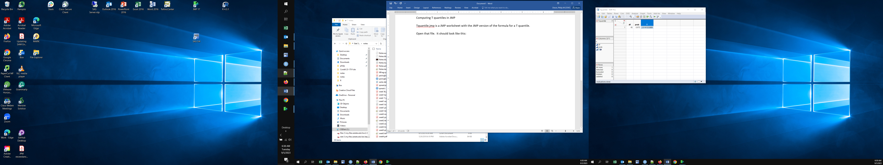

Click on a cell in the df column and enter the necessary degrees of freedom

Click on a cell in the prob column and enter the desired probability and hit enter / return

(remember this is not the coverage – see lecture notes if that’s not clear)

The T column will automatically recompute.

If you want to compare T quantiles, you can enter additional rows of data. You need to specify values of df and prob for each T quantile you want.